**SMOKE ALARM IN TINKERCAD USING IOT**

**Smoke alarm in tinkercad using arduino in iot**

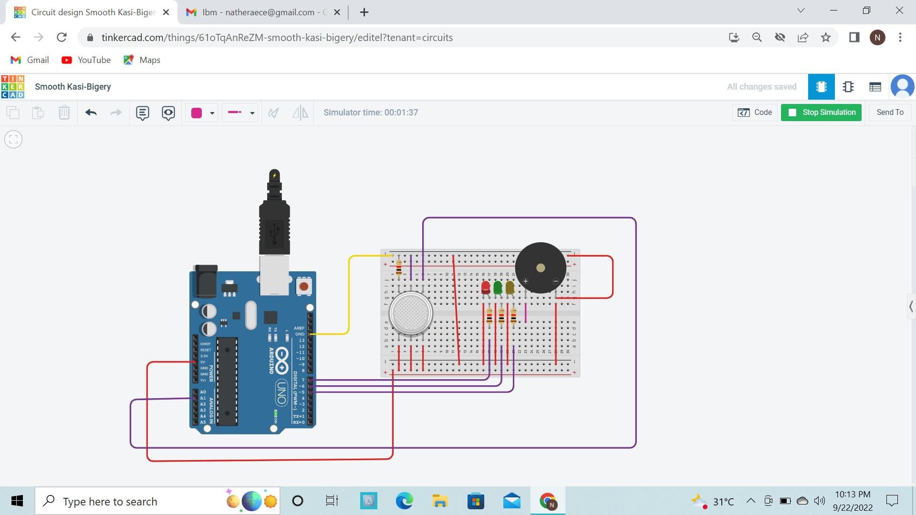

**Components**

**Arduino**

**Bread Board**

**LED x3**

**Buzzer**

**Gas sensor**



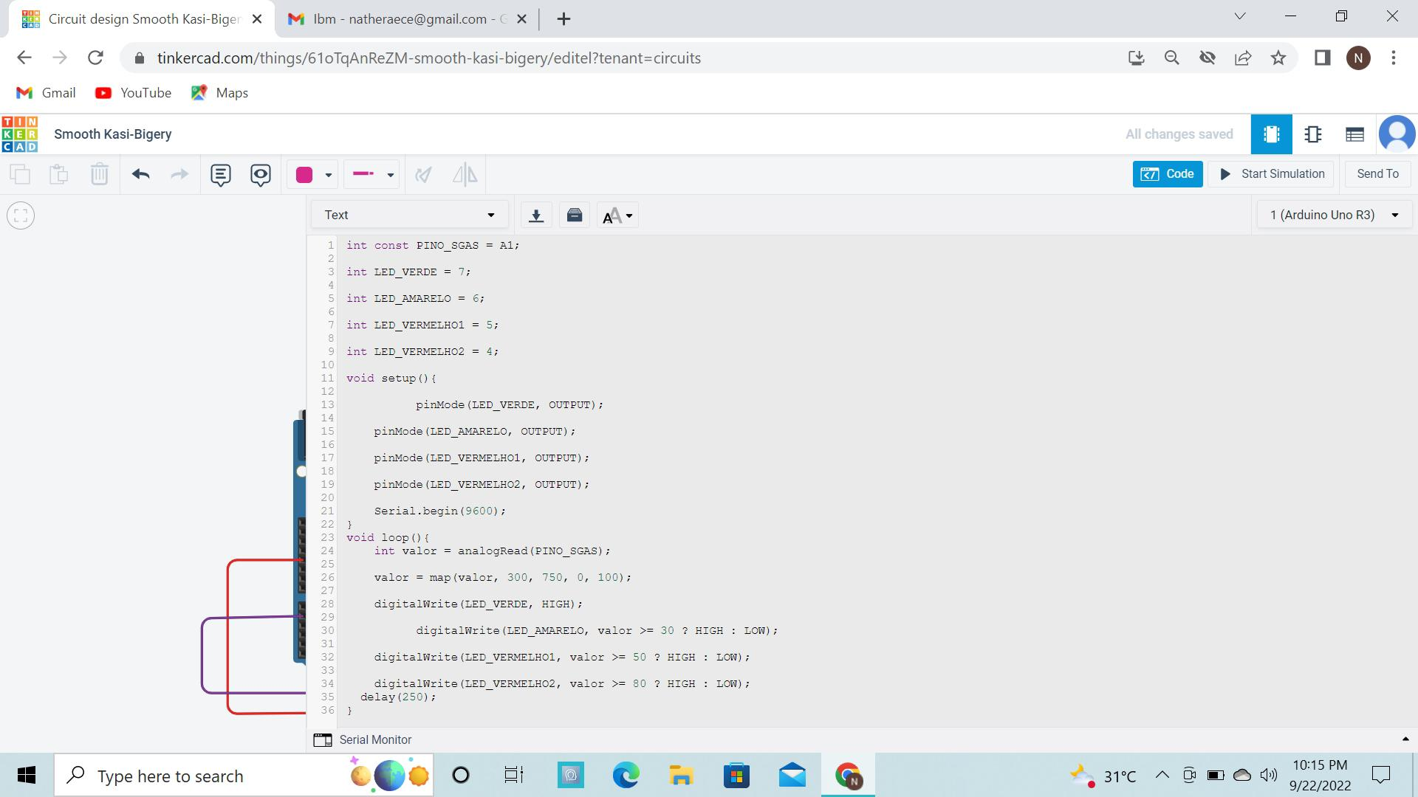

**Coding**

**Int const PINO_SGAS = A1;**

**Int LED_VERDE = 7;**

**Int LED_AMARELO = 6;**

**Int LED_VERMELHO1 = 5;**

**Int LED_VERMELHO2 = 4;**

**Void setup(){**

**pinMode(LED_VERDE, OUTPUT);**

**pinMode(LED_AMARELO, OUTPUT);**

**pinMode(LED_VERMELHO1, OUTPUT);**

**pinMode(LED_VERMELHO2, OUTPUT);**

**Serial.begin(9600);**

**}**

**Void loop(){**

**Int valor = analogRead(PINO_SGAS);**

**Valor = map(valor, 300, 750, 0, 100);**

**digitalWrite(LED_VERDE, HIGH);**

**digitalWrite(LED_AMARELO, valor >= 30 ? HIGH : LOW);**

**digitalWrite(LED_VERMELHO1, valor >= 50 ? HIGH : LOW);**

**digitalWrite(LED_VERMELHO2, valor >= 80 ? HIGH : LOW);**

**delay(250);**

**}**